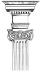
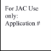
Jericho Arts Council
CALL FOR ARTISTS
Bainbridge Arts Trail -“Regatta Row 2023”
In celebration of the 60th Annual General Clinton Canoe Regatta, The Jericho Arts Council (JAC) is inviting you to bring out your Art in Bainbridge, New York! JAC has teamed up with the Bainbridge Chamber of Commerce, regional businesses and artists to create Bainbridge Arts Trail - “Regatta Row 2023”. Regatta Row is now accepting applications from artists who wish to participate in Regatta Row’s 9th year, featuring 15 Adirondack Paddle chairs, and 5 childrens Adirondack Paddle chairs. Art will be exhibited on Main Street (Intersection of Routes 7 & 206) in historic downtown Bainbridge, NY throughout May and then auctioned at the Canoe Regatta to benefit the JAC. Artists and designers must submit an application by the deadline of February 4, 2023 to be selected to create a unique chair. We hope you will tell stories, translate emotions, and inspire creativity & original thinking through your interpretation of our theme this year: Books by the Riverside. You can create with your favorite book, a great afternoon read or any book that might make one take a break by the Riverside.
Supplies and Recognition for Selected Artists:
● Chair: Wood Adirondack style Paddle Chair, to use as a canvas for art, decoration and/or carving. Chairs may be modified structurally, but must be usable and safe. Chairs are displayed outdoors and must be able to withstand weather.
● Paint: Paint will be provided by JAC for use on Chair.
● Public Relations: JAC Plaques on each piece with Artist’s name and title; Artist’s name and artwork locations listed on a map of the Bainbridge Art Trail/Regatta Row; Artist bios on the JAC website, Facebook and Instagram; Press releases to the media. Canoe Regatta publications and live Auction marketing.
● Cash Awards: Recognize outstanding Artists with Awards of Excellence, Best in Show, etc.
● Stipend: Each artist will receive a stipend in appreciation of their time & talent for the completed chair .

Deadline for Applying: Artists 18 and older are welcome to apply individually or in groups/organizations Hard copy, or digital application must be postmarked or delivered by FEB. 4 2023 Mail to: JAC c/o 63 N. Main Street, Bainbridge, NY, 13733 or E mail: jacarttrail@gmail.com Applications: Go to Jericho Arts Council (JAC) website: www.jerichoarts.com Click on “Regatta Row 2023”. Results: Submissions will be juried and invitations to participate will be awarded by February 17, 2023 via e-mail or telephone.
QUESTIONS: e-mail jacarttrail@gmail.com or call Rachel at (607)643-2211
1. Application: Artists (age 18 and up) must submit the application including a sketch or storyboard of their proposed design, bio & examples of past work, for review by the JAC jury.
2. Function: Structure of chair may be modified, carved or decorated, but still safe and usable.
3. A "Family Style" Show: Artwork deemed inappropriate will be rejected at the discretion of the judges
4. Responsibility: All costs to paint or decorate the Chair or Story Pole, including transportation to downtown Bainbridge, are the responsibility of artists unless otherwise noted. (Paint, primer & top coat and chair(s) will be provided). Application will imply agreement with this disclaimer. Chairs copyright and art upon them are the sole property of the JAC Gallery Committee, and may be used for promotion of the arts and auctioned or sold to help the promotion of the Arts in Bainbridge.
5. Artist Timeline 2023:
a. February 4: Application to be received; or postmarked no later than Saturday Feb. 4th
b. February 17: Artist Selection is announced via e-mail or phone.
c. late Feb: Chairs available to selected artists for pickup.
d. April 22: Artists deliver completed chair to Bainbridge.
e. April 29: Exhibit Opens
f. April 29 to May 26: Public online auction bidding and voting for “People’s Choice Award.”
g. May 27:: Regatta Row Live Auction at General Clinton Canoe Regatta

Regatta Row - Application 2023

Name of Artist or Group: ______________________________________
Please specify -Professional Artist/Designer, Organization/Group, College Student, Non Professional Artist/Designer Older than 17 by May 1 2023 yes_____ or no_____
Contact Person: ___________________________________
Phone number: _____________________________
E-mail Address: ___________________________________________________________________
Mailing Address: _________________________
Web Site/social media (if applicable):__________________________________________________________ Indicate preference: Chair _____ or Childrens Chair _____ Either or both
Biography: Please attach a one paragraph biography describing your experience related to the Arts or an Artist’s Statement. Organizations or groups may describe their reason for participation and if possible, the experience of key artists.
Accepted Application formats: Mail Hard Copy postmarked or delivery by FEBRUARY 4 2023 to: JAC c/o 63 N. Main Street, Bainbridge, NY 13733 - OR electronic files emailed to jacarttrail@gmail.com (preferred method of application)
Sketch: Show your design concept for the Paddle Chair, including the top view of 1 or both arms and the front view of the chair. Include your plan for the back and legs of chair. You may draw directly on the blank Sketches provided or on separate paper (note the chair back will be spaced). A “storyboard” may also be submitted with samples of art, colors, material, textures, etc.
Photos: Include 3 photos of any other artwork that shows your styles and diversity-previous RR artists exempt. By accepting an invitation to “create” a chair, you agree to your art being viewed on JAC website for public voting and auction.
Questions: Send questions and your phone number to: jacarttrail@gmail.com or call Rachel at 607-643-2211
Agreement: Applications are property of JAC and will not be returned. I agree to abide by these Rules and Regulations, and all attachments. I also agree to assume the risk of loss to my art, and other property of myself and my affiliates whether from breakage, damage, loss, theft, disappearance or any other cause before delivery. I understand the Paddle Chairs and artwork on them are the property of the Jericho Arts Council Gallery Committee and images may be used for promotion of the arts and these artworks will be auctioned or sold. Further, I agree to indemnify and save the Event Organizers, The Jericho Arts Council and JAC Gallery Committee and all Sponsors and crew harmless from any and all claims, actions, damages, liability and expense, including attorney’s fees, in connection with loss of life, personal injury and/or damage to property that may be done or suffered by reason of my fault or negligence in the performance of or negligence in the performance of or failure to perform my responsibilities as stated in this application and enclosed Rules and Regulations, or occasioned all or in part by any act or omission by myself, my agents, volunteers or employees.
Printed Name____________________________________________________________________________________________
Signature________________________________________________________________________________________________ Date_____________________________________________________________________________
Thank you for submitting your application! Already, you are part of the stream of creativity that flows into Bainbridge
and the surrounding regions. THANK YOU from the Jericho Arts Council Gallery Committee!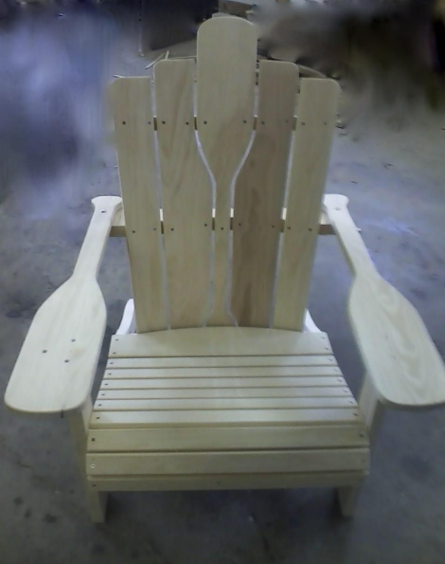
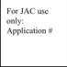
Front of chair seat back
Top edge will be staggered as in photo above Top of Paddle is 40” high (child’s 28” high)
Seat of chair is 21” wide ( child’s 18” wide)
