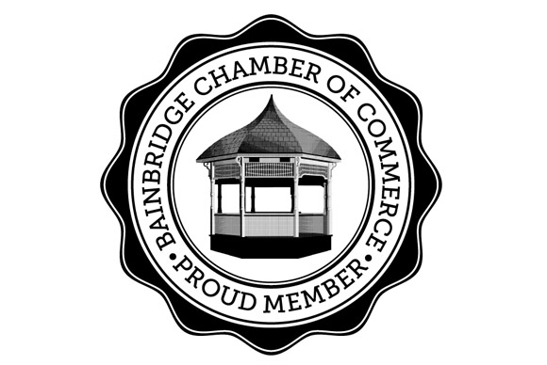
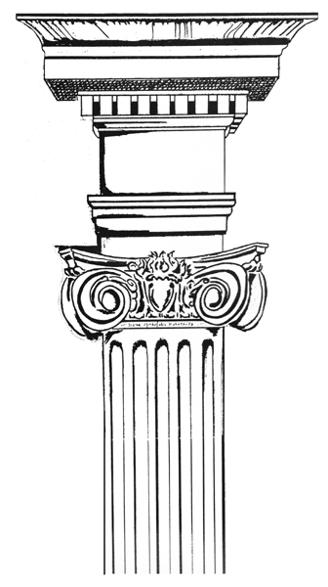
Jericho Arts Council Gallery Committee Web: www.jerichoarts.com Email: jacarttrail@gmail.com
Jericho Arts Council and the Bainbridge Chamber of Commerce
presents the Premiere of
Regatta Row 2018 - Street Art Fest Free Business Advertising & PR
Saturday April 28, 2018 2 to 4:00 PM
Main Street & 206, from Jerry’s Inn to Bob’s Diner (rain? Go Into Town Hall)
Together we can use Art to draw Business

Return Business/Vendor Registration to: jacarttrail@gmail.com or 2 Juliand Street Bainbridge NY 13733 Questions? Call Nancy 908-347-0091

Business Name_______________________________________________

Owner/s____________________________________________________

Contact Person_______________________________________________

Contact’s Phone #____________________________________________

Address____________________________________________________

E Mail______________________ Business Phone #_________________

This is a free event, but we encourage each business to give some small thing to visitors, (coupons, sweets, pens or anything that makes you memorable) We will promote your business online and in media. All artists, musicians & restaurants volunteer to create this event.
A) I will set up a table in front of my business:______________________________

Or B) I don’t have a store front in the village & need an assigned place___________

I will not set up a table, but ask JAC to put out my Literature___________________

Any of the following are appreciated, but certainly optional. Please disregard if you have already donated:
I will donate a product or service to be raffled on April 28 _____________________

My raffle item will be: ____________________________Estimated Value________

I want to sponsor a donation of $ ____ to the JAC to support Regatta Row Art & Artists
I assume all responsibility for participation in this event. I understand that the JAC, Gallery Committee and Bainbridge Chamber of Commerce shall be held exempt from any liability for any incident related to the production or in the course of this event.

Name (print)_________________________________________________________________

Signature______________________________________________________________________
The JAC & Bainbridge Chamber of Commerce, thank you for participating!
Sponsors: Chenango Arts Council; Golden Artist Colors, Lambrecht Auction

