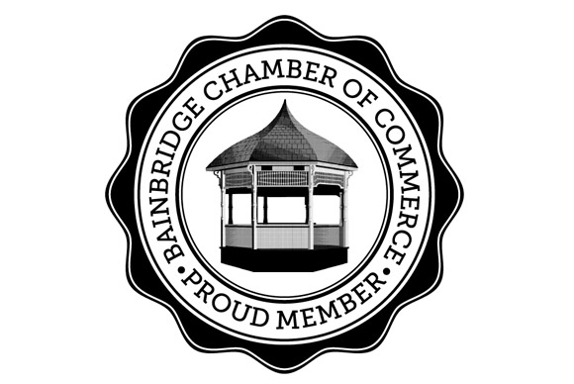
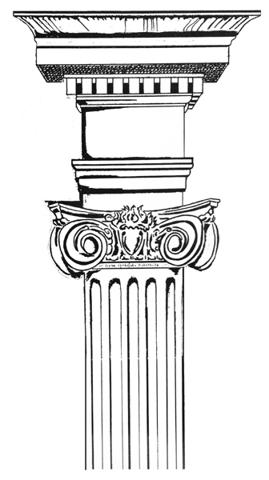
Jericho Arts Council
JAC Gallery Committee 2 Juliand St. Bainbridge, NY 13733
jacarttrail@gmail.com www.jerichoarts.com
Jericho Arts Council and the Bainbridge Chamber of Commerce
present the Premiere of
Regatta Row 2018 – Bainbridge Street Art Fest
Sponsorship & Community Outreach through Art
In celebration of the 56th Annual General Clinton Canoe Regatta, the Jericho Arts Council (JAC) with the support of the Bainbridge Chamber of Commerce invite you and/or your organization to help bring out the Arts in Bainbridge! JAC has once again teamed up with regional businesses and artists to create the Bainbridge Arts Trail – Regatta Row 2018. This will be an outdoor Art exhibition with a new category. The Classic Canoe Paddle Chairs are complemented with artist designed and decorated Adirondack style, small Folding End Tables. Saturday. April 28, Regatta Row Street Art Fest has a new time, from 2 to 4:00 PM at N. Main St (Rt 7) & Rt 206 in downtown Bainbridge. The art is accessible 24 hours a day, for the month of May until the auction benefiting the JAC/Bainbridge Arts Trail, on Saturday, May 26 the auction is at 3:00 PM, immediately before the Chamber of Commerce Hall of Fame Awards and during the Michelob Ultra Happy Hour in the Chamber Tent at General Clinton Park Regatta Field.
Individuals & Business:
$50 - $249 Bronze :
Names listed on JAC sign, displayed at General Clinton Park on Regatta Weekend (May 25-28)
Community recognition with your name listed in the online event journal Participate in the Meet the Artists Premiere “Bainbridge Street Art Fest” with live music, free raffles, food on Saturday April 28 (no charge for booth ) Opening night “Street Art Fest”: You can set up a free display table promoting your company products and services
$250-$499 Silver : All Bronze benefits plus:
Your company name on plaque mounted on base of table or chair
$500-$599 Gold : All Silver and Bronze benefits plus:
Your company name only on plaque mounted on base of table or chair
Artwork will be displayed in front of your Bainbridge business or on Main Street (your choice)
Your company name listed in all programs and maps (print and online)
Participate in the Media Conference on Wed, April 25 at 11:30 AM at Town Hall (TV & Press in past)
$600 + Platinum : All Gold, Silver and Bronze benefits plus:
Preferred location for placement of sponsored artwork
Name listed in local newspaper advertising
For 5 weeks, your Company name on 25’ long Regatta Row banner hung over main intersection in town
6 pack Passes to JAC musical performances at Bainbridge Town Hall Theatre
Saturday April 28 all merchants are encouraged to participate in the “Meet the Artists – Regatta Row Street Art Fest”. As a sponsor, you are invited to join the other businesses and have an open house from 2 to 4 pm. The JAC will promote the evening's festivities with live music, and artists will be on hand for the premiere of their work
YES I want to support Regatta Row 2018 with a donation/pledge of $____________________________
YES I want to make a Raffle prize donation of: _______________________________________________________
Name:________________________________________________________________________________________________________

Business:____________________________________________________________________________________________________

Phone #:________________________________________ Email:_____________________________________________________
Please Respond to: Nancy Kitchen: jacarttrail@gmail.com T: 908-347-0091 Website: www.jerichoarts.com
Checks can be made to: Jericho Arts Council with memo “Regatta Row “ Address: JAC c/o 2 Juliand St Bainbridge NY
Thank you so much!
Jericho Arts Council – Gallery Committee and Regatta Row 2018

