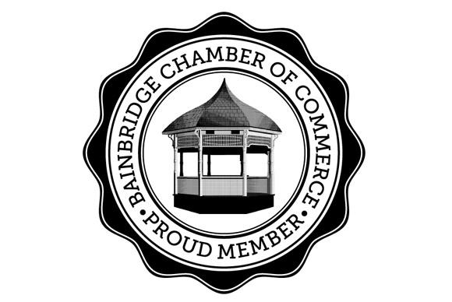
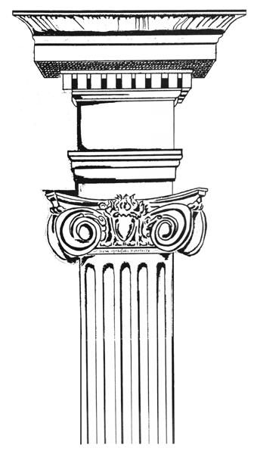
Jericho Arts Council
jacarttrail@gmail.com www.jerichoarts.com

Jericho Arts Council and the Bainbridge Chamber of Commerce
present the 10th Annual month long Celebration of
Regatta Row 2024 – Street Art Exhibition
“Celebrating the Regatta!”
Sponsorship & Community Outreach through Art
In celebration of the annual General Clinton Canoe Regatta, the Jericho Arts Council (JAC) Gallery Committee, with the support of the Bainbridge Chamber of Commerce, invite you and/or your organization to help bring out the Arts in Bainbridge! JAC has once again teamed up with regional businesses and artists to create the Bainbridge Art Trail: Regatta Row 2024. This will be an outdoor Art exhibition. The Classic Canoe Paddle Chairs are complemented with Rocking Chair versions on Display April 27th - May 24th at N. & W. Main St in downtown Bainbridge. The art is accessible 24 hours a day, for the month of May until the auction benefitting the JAC/Regatta Row, on Saturday, May 25 at the General Clinton Park Regatta Field.
Regatta Row 2024 Street Art & Music Fest – Saturday April 27, 1-4 PM North & West Main Streets
***Restaurant, Business & Organization Participation encouraged and appreciated***

Individual & Business Sponsorship
$50 - $249 Bronze
Names listed on JAC sign, displayed at General Clinton Park on Regatta Weekend, Auction on May 27
Community recognition with your name listed in online postings and the maps.

$250-$499 Silver
All Bronze benefits plus:
Your company name listed in all programs and maps (print and online).

$500-$599 Gold
All Silver and Bronze benefits plus:
Your company name (only) on plaque mounted on base of chair
Artwork can be displayed in front of your Bainbridge business on Main Street
$600+ Platinum
All Gold, Silver and Bronze benefits plus:
Preferred location for placement of sponsored artwork
Name listed in local newspaper, radio and social media advertising
6 Passes to JAC musical performances at Bainbridge Town Hall Theatre
NEW BENEFIT: 12 months of Membership to the Jericho Arts Council including Sponsorship listing in every JAC Theatre program for the year. Special mention during live auction at General Clinton Canoe Regatta.

Your generous support of the arts helps honor our artists and musicians with stipends and awards and helps create future events!

YES I want to support the Bainbridge Arts Trail with a donation/pledge of $_______________

Name:__________________________________________________________________________
Business:_______________________________________________________________________
Phone #:_____________________________________
Email:_______________________________________

For Additional Info: jacarttrail@gmail.com Rachel Hares: 607-643-2211
If sending donation by mail: Regatta Row 2023 ℅ Cookie Witham, 63 N.Main St, Bainbridge, NY 13733
To be included on Art Trail maps and posters, please respond by March 29

Thank you so much! Jericho Arts Council – Gallery Committee/Regatta Row 2024

